––––––––









 HEMALATHA.R

MONIKA.E



ROHINI.B



 PUSHPARANI.B

YOGALAKSMI.M





:

The employees need a quicker and more reliable way to request laptops for their work. The current manual process causes delays and doesn’t provide smart, interactive features to guide users or ensure the information they enter is correct. To fix this, a Service Catalog item should be created that allows employees to request laptops easily. The form should have dynamic fields, clear instructions, and an option to reset it if necessary. Additionally, the system must include complete change tracking to maintain proper governance and manage deployments effectively.

:



Created and set up interactive Service Catalog items in ServiceNow to streamline hardware request submissions. Customized client scripts, UI policies, and catalog UI pages to make the forms intuitive and easy to use. Applied validations, dependencies, and conditional rules to maintain accurate data entry.

Implemented approval workflows and audit tracking to ensure compliance and proper governance.





1. Open ServiceNow.
2. Go to All, then use the search field to find Update Sets.
3. In the System Update Sets section, select Local Update Sets.
4. Click New to create a fresh update set.
5. Fill in the required information and give it the name “Laptop Request.”
6. Press Submit, then set it as the current update set.

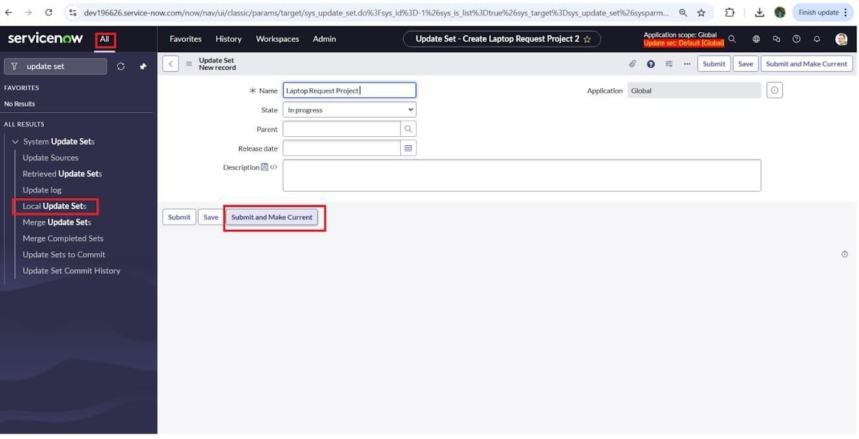

  





1. Open ServiceNow.
2. From the All menu, type Service Catalog in the search bar.
3. In the Catalog Definitions section, select Maintain Items.
4. Press New to set up a fresh catalog item.

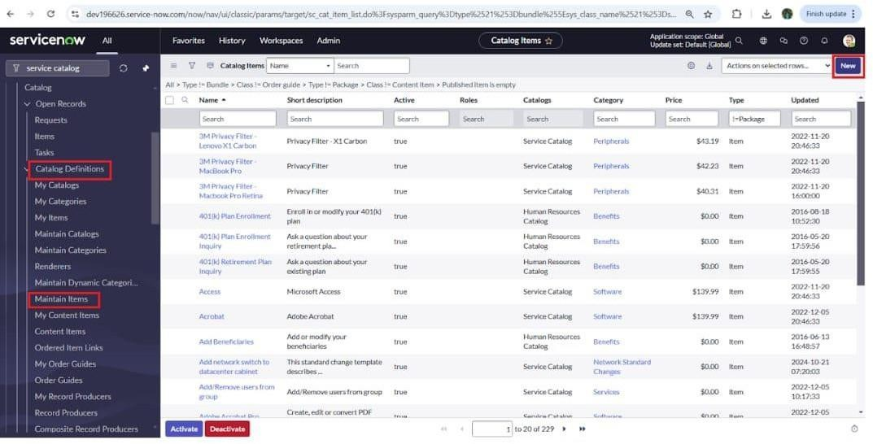

1. Provide the required details to create a new catalog entry:
2. Item Name: Laptop Request
3. Catalog: Service Catalog 4.Category: Hardware
4. Brief Description: Submit this form to request a laptop.
5. After completing all fields, select Save to record the item.

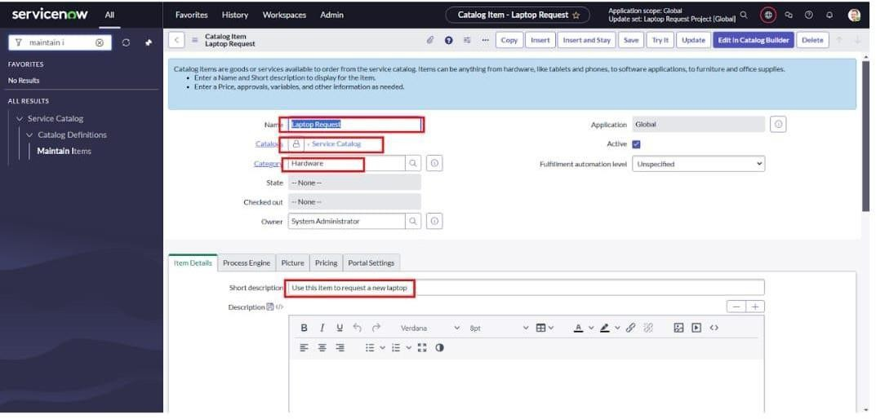





* + Once the catalog item is saved, navigate to the Related Lists section and select Variables.
  + Choose New, then enter the following information:
    1. Variable 1:
       - Label: Laptop Model
       - Type: Single Line Text
       - Name: laptop_model
       - Order: 100
  + Click Submit to store this variable.
  + Repeat these steps using New again to create any additional variables.

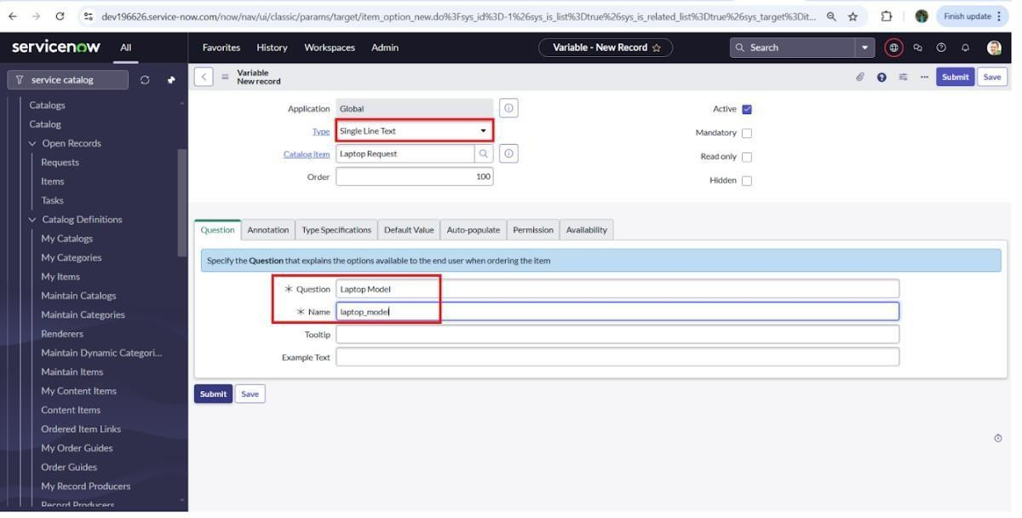

* + 1. Variable 2: Justification

Type: Multi-line Text Name: justification Order: 200

* + 1. Variable 3: Additional Accessories Type: Checkbox

Name: additional_accessories Order: 300

* + 1. Variable 4: Accessories Details Type: Multi-line Text Name: accessories_details Order: 400



* + After adding the above variables to the catalog item you created,
  + Be sure to save the catalog item form.

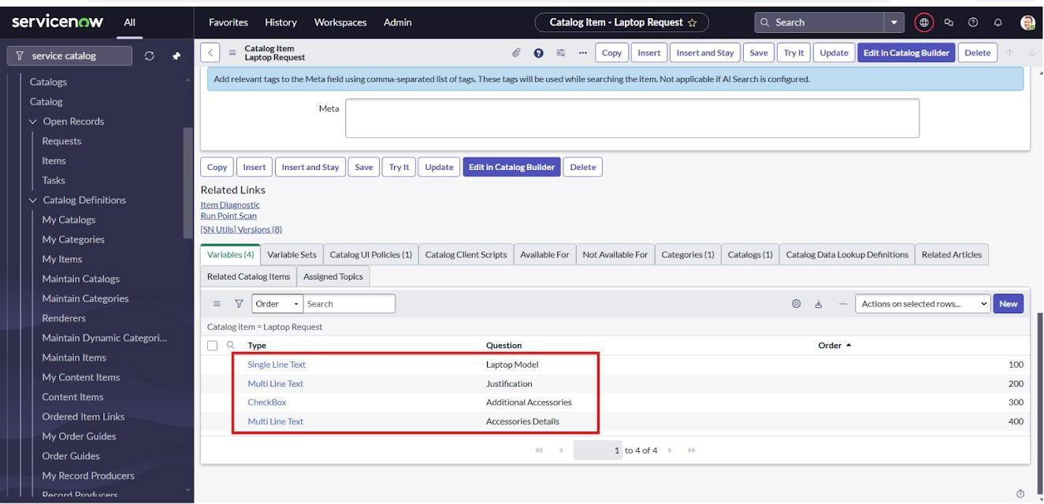









1. Open All in ServiceNow and search for Service Catalog.
2. Under Catalog Definition, select Maintain Items.
3. Locate the catalog item you created earlier, Laptop Request.
4. Open the Laptop Request record, scroll down, and choose the Catalog UI Policies tab.
5. In the Catalog UI Policies related list, click New to create a new policy.
6. Enter Show Accessories Details in the Short Description field.
7. In the When to Apply section, configure the condition as follows:
   * Field: additional_accessories
   * Operator: is
   * Value: true
8. Click Save (don’t click Submit yet).
9. Scroll down to the Catalog UI Policy Actions section and click New.
10. Fill in these details:
    * Variable Name: accessories_details
    * Order: 100
    * Mandatory: True
    * Visible: True
11. Click Save, then save once more on the main Catalog UI Policy form to finalize the changes.

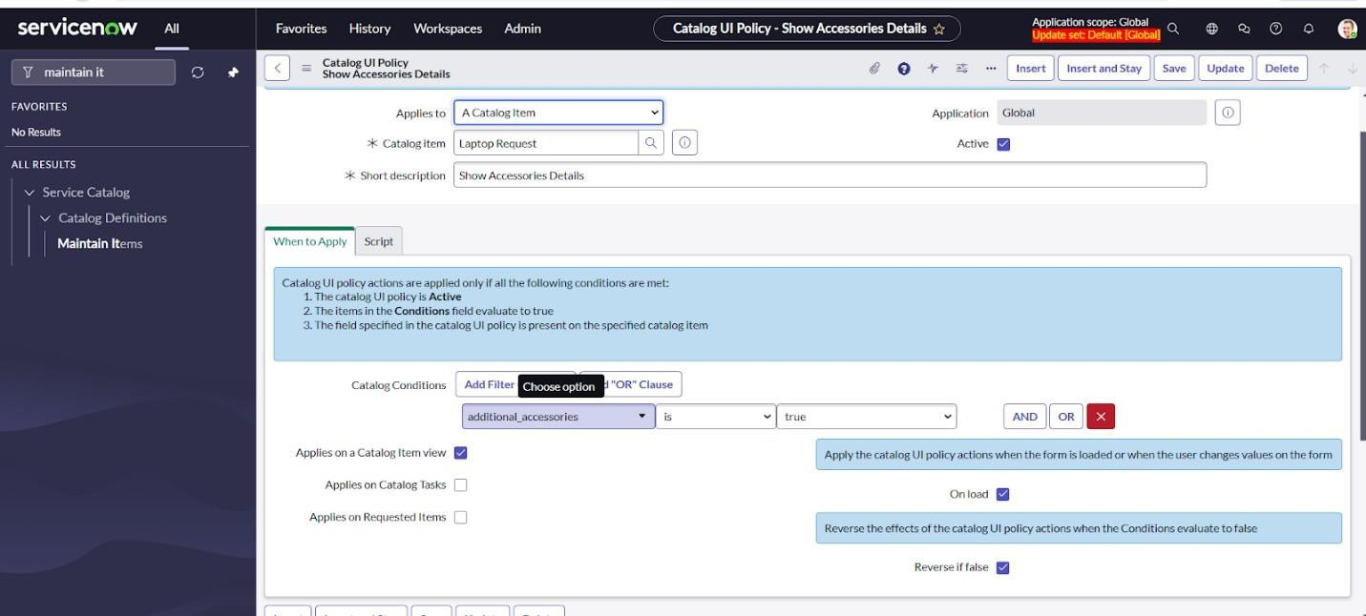

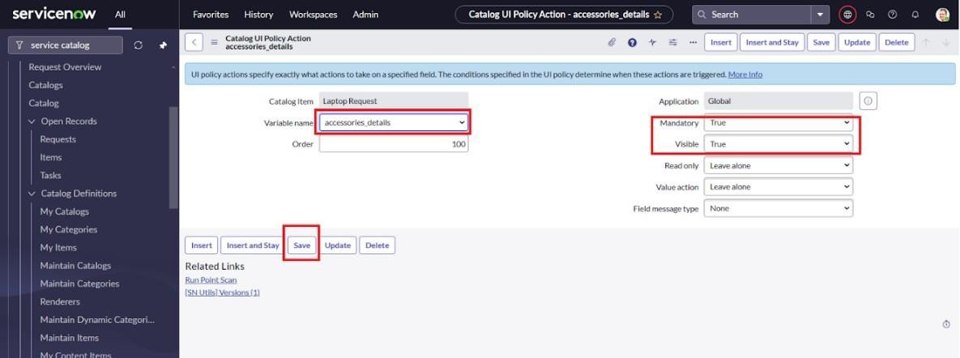

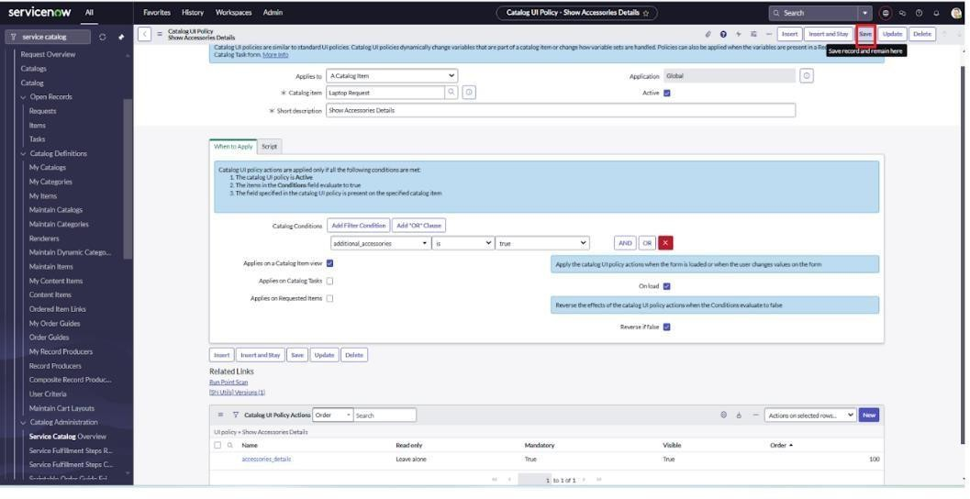









1. Sign in to ServiceNow.
2. From the All menu, type UI Action into the filter navigator.
3. Under System Definition, select UI Actions.
4. Click New to create a fresh UI Action.
5. Complete the fields as follows:
   * Table: Shopping Cart (sc_cart)
   * Order: 100
   * Action Name: Reset form
   * Client: Tick this option to make it a client-side action.
6. In the Script section, add this code:

function resetForm() {

g_form.clearForm(); // Clears all form fields alert("The form has been reset.");

}

1. Press Save to store and apply the new UI Action. Click on save

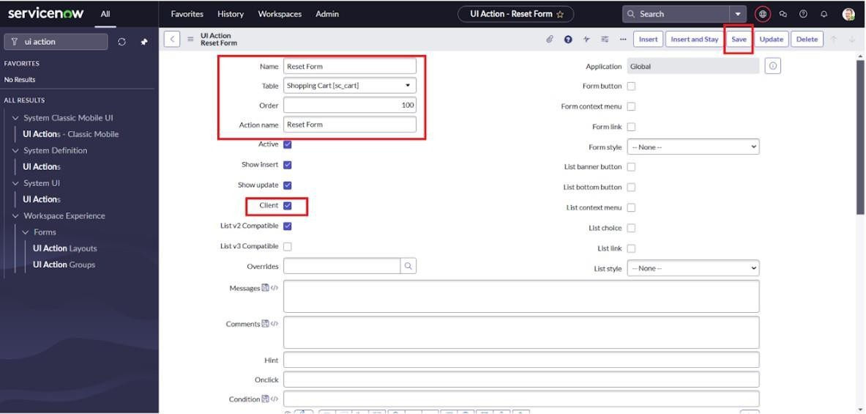

1. In ServiceNow, open All and search for Update Sets using the navigation filter.



1. Select Local Update Sets.
2. Find and open the update set you created earlier, “Laptop Request Project.”
3. Set the State field to Complete.
4. Under the Updates tab in the related list, review all the modifications included in this update set.
5. Click Export to XML to download the file.

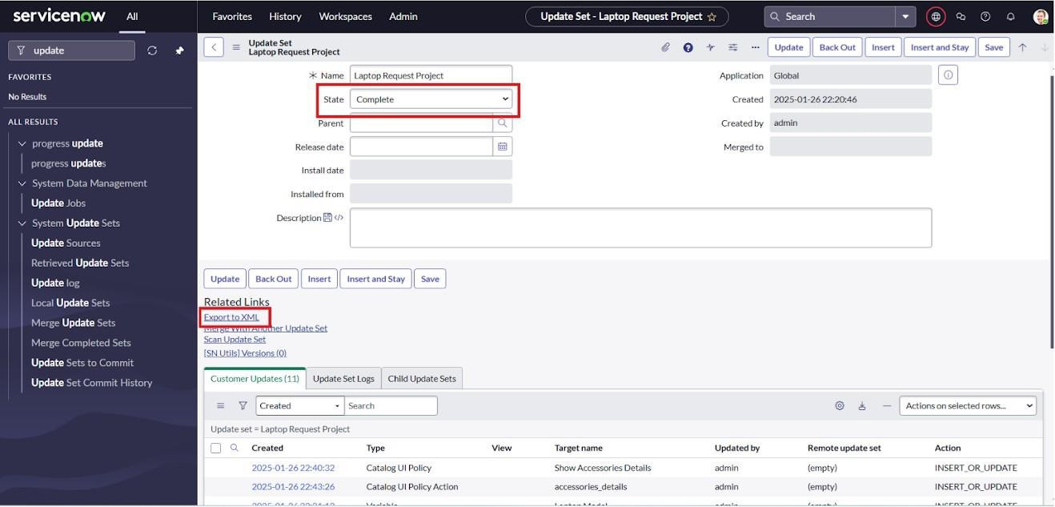









1. Launch a private (incognito) browser window and open a different ServiceNow instance.
2. Sign in with your login details.
3. From the All menu, type Update Sets into the search bar.
4. Under System Update Sets, choose Retrieved Update Sets.
5. A list of retrieved update sets will appear—scroll down to proceed.
6. Select Import Update Set from XML.
7. Browse for and upload the XML file you downloaded earlier.
8. Click Upload to add the update set to this instance.
9. Locate and open the retrieved update set titled “Laptop Request Project.”
10. Click Preview Update Set to examine the pending changes.
11. Once verified, click Commit Update Set to apply the updates.
    1. Be sure to review the Updates tab in the related list.
    2. Once the update set is committed in this instance, all the changes from the previous instance will be applied here.

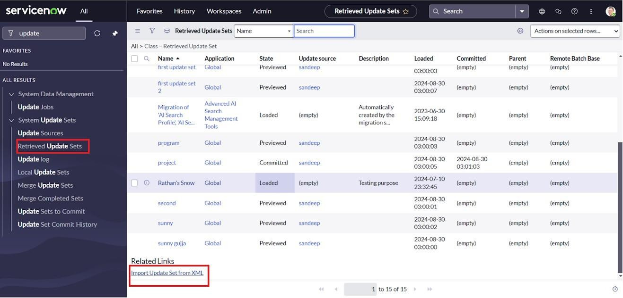

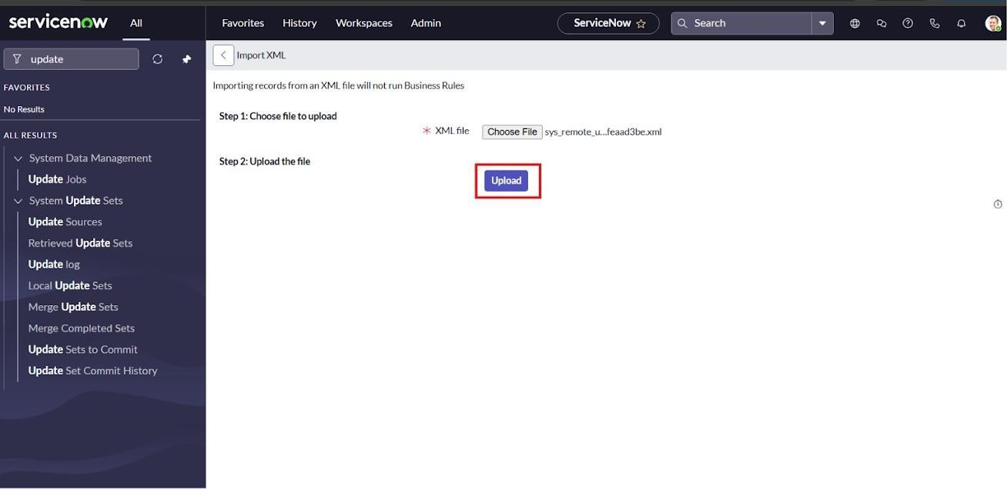

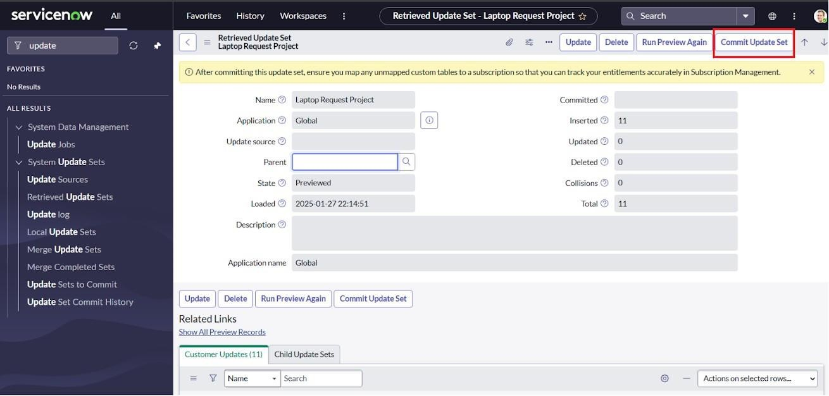





1. Navigate to the Application Navigator in the target instance and look for Service Catalog.
2. Within Service Catalog, select Catalog.
3. Go to the Hardware category and locate the Laptop Request item.
4. Open the Laptop Request catalog item.
5. Initially, you will notice that only three fields are visible.
6. Based on our configuration, selecting the Additional Accessories checkbox should make the Accessories Details field appear and mark it as mandatory.
7. Verify that this functionality works correctly and aligns with the requirements.

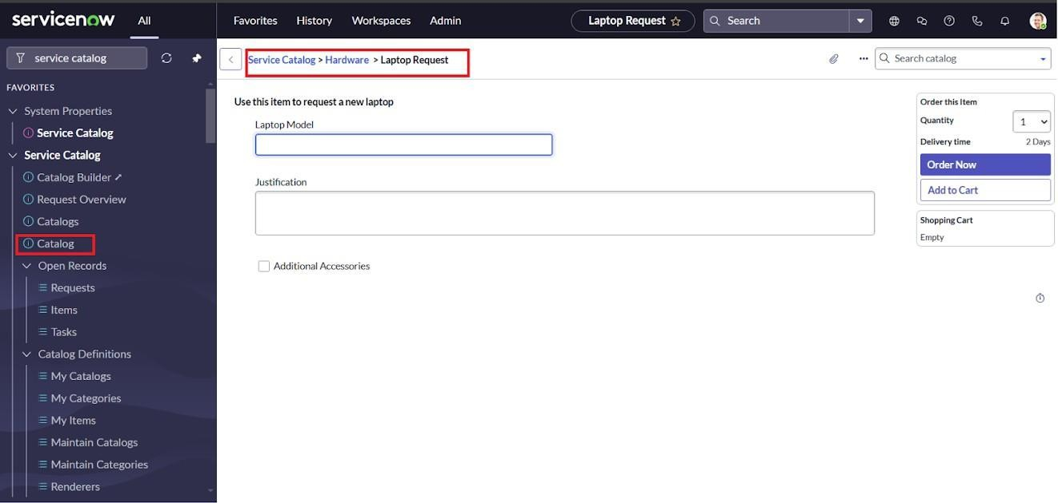

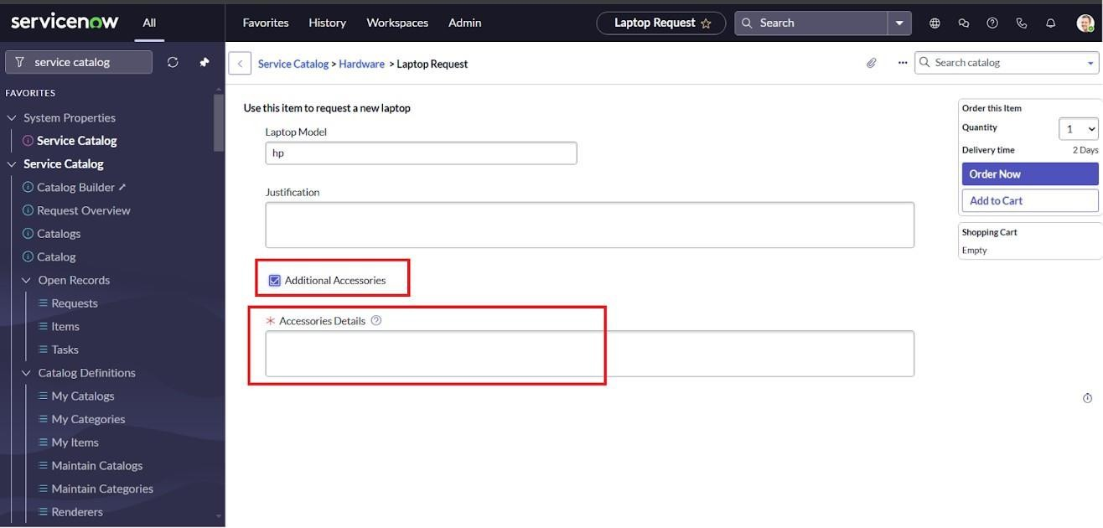



The Laptop Request Catalog Item project effectively simplifies the process of requesting laptops within the organization by utilizing the capabilities of ServiceNow’s Service Catalog. By creating a dynamic catalog item, the project provides users with an intuitive and easy-to-use interface, minimizing errors and boosting efficiency. This initiative illustrates how ServiceNow can replace manual, error-prone workflows with automated, streamlined, and user-focused solutions. Beyond improving service delivery, it also enhances employee satisfaction by offering a modern and seamless request experience.

.